Project Design Phase-II
Data Flow Diagram & User Stories

Date | 20-10-26
Team ID
Project Name | IMovies
Maximum Marks | 4 Marks

Data Flow Diagrams:
A Data Flow Diagram (DFD) illustrates how data moves within the IMovies – Movie Ticket Booking System. It represents how users interact with the system to browse movies, view showtimes, check seat availability, and book movie tickets. It also shows how data flows between the system, the database, the administrator, and the payment gateway, including the storage and retrieval of user information, movie details, showtime records, booking records, and payment information.

Example: DFD Level 0 (Industry Standard)
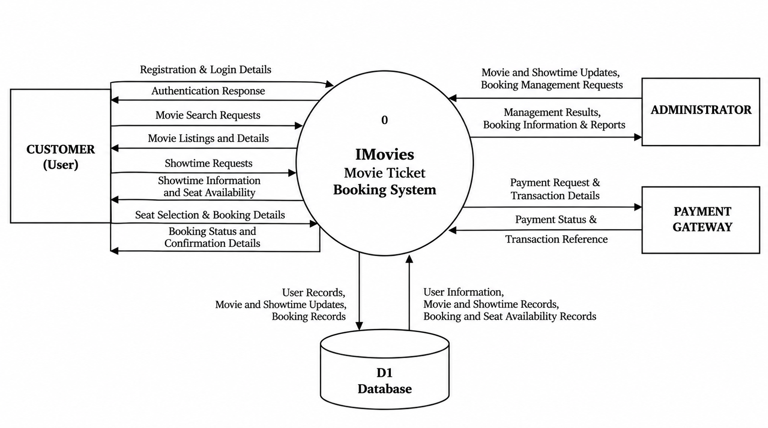

User Stories

User Story Table – IMovies : Movie Ticket Booking System
User Type | Functional Requirement (Epic) | User Story / Task | Acceptance Criteria | Priority | Release
User | User Authentication | As a user, I can register for an account and log in to access the IMovies platform. | User can register with valid details and log in successfully with valid credentials. | High | Sprint-1
User | Movie Browsing | As a user, I can browse available movies to explore currently listed films. | Available movies are displayed with relevant details. | High | Sprint-1
User | Movie Search | As a user, I can search for movies by title to find a specific film. | Search results display movies matching the entered title. | High | Sprint-1
User | Movie Details | As a user, I can view movie details to learn more before booking a ticket. | The selected movie's available details are displayed correctly. | High | Sprint-1
User | Showtime Management | As a user, I can view showtimes for a selected movie to choose a suitable screening. | Available showtimes for the selected movie are displayed. | High | Sprint-1
User | Seat Availability | As a user, I can check seat availability for a selected showtime before booking. | The system displays available seats for the selected showtime. | High | Sprint-2
User | Ticket Booking | As a user, I can select seats and book tickets for a movie show. | The system processes the booking request and displays the booking status. | High | Sprint-2
User | Booking Confirmation | As a user, I can view my booking confirmation and ticket details after booking. | The system displays the booking status and relevant ticket details. | High | Sprint-2
Administrator | Movie Management | As an administrator, I can add, update, and manage movie listings. | Changes to movie listings are saved and reflected in the system. | High | Sprint-1
Administrator | Showtime Management | As an administrator, I can manage movie showtimes and related information. | Updated showtime information is stored and displayed correctly. | High | Sprint-1
Administrator | Booking Management | As an administrator, I can review booking records to monitor ticket reservations. | Booking records can be retrieved and viewed correctly. | Medium | Sprint-2
System | Payment Processing | As a user, I can pay for my ticket booking through an integrated payment gateway. | Payment status is processed and associated with the relevant booking. | High | Sprint-2

